Heraldic Banner
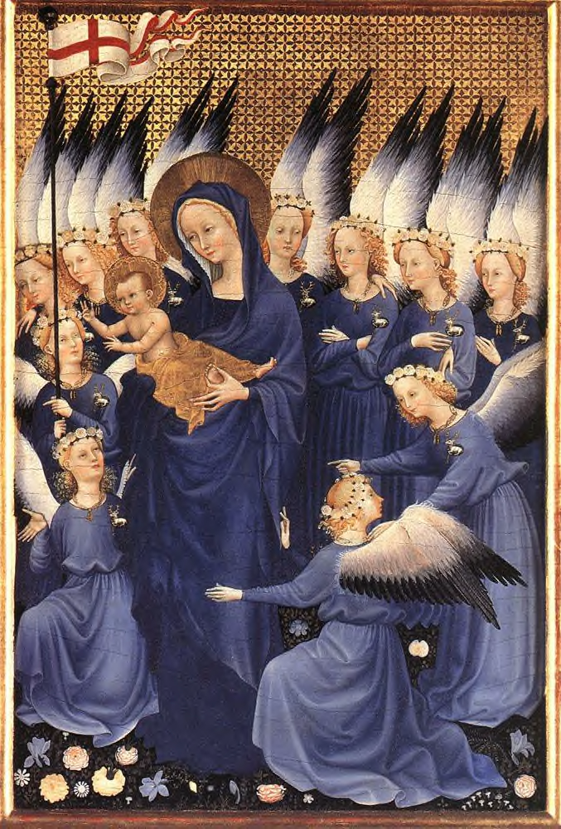

Dame Claire Tønnesdtr
Crown War 2004

The entry is a heraldic banner made of wool
with hand appliquéd charges and
hand-embroidered detailing.

UNKNOWN MASTER, French
Wilton Diptych: Virgin and Child with Angels
1395
Tempera on oak panel, 36,8 x 26,7 cm
National Gallery, London

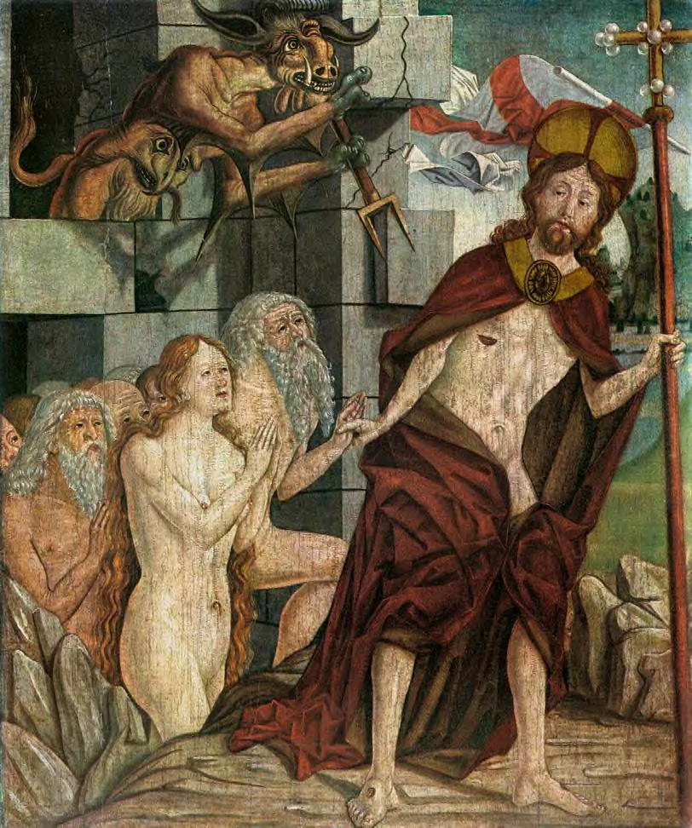

PACHER, Friedrich
Christ in Limbo
1460s
Tempera on pine panel, 85 x 71,5 cm
Museum of Fine Arts, Budapest
An example of a gonfalon

Heraldic banners of many differing sizes and shapes are well documented throughout our time period. What is not so well documented is their construction. Although the separate elements of this particular banner are readily documented, all of them together are not. I leave it to the worthy judges to determine the overall authenticity.

Heraldic banners were used extensively, throughout Europe, by the nobility and royalty as a method of quick identification.

The piece itself is my personal device, Sir Nigel Seymour recently approved the heraldic design; I offer this as expert opinion that the overall design is of a period design.

The style of this banner is called a “gonfalon”, which means that it is supported by a horizontal support. They may have one or more “tails”. I have learned through much research that this type of banner was rather unusual in our time period, mainly used by the Church, More typical are the rectangular and square banner types supported by a vertical bar.

Also 1500-1800 gonfalone. [adopted from lt. gonfalone, Portugese gonfalào, Spanish confalon, French gonfalon later form of GONFANON.]
A banner or ensign, frequently composed of or ending in several tails or streamers, suspended from a cross-bar instead of being directly fastened to the pole, especially as used by various Italian republics or in ecclesiastical processions.
1595 T. BEDINGFELD translation of Macchiavelli's Florentine history (tr. 1594) 73 For it sufficed that anie one man cried, let vs goe to such a place, or holding the Gonfalone by the hande, looked that way. [DMH: post-1600 entries not included] The Compact Edition of the Oxford English Dictionary, Oxford University Press, 1971.

The appliquéd charges of keys were attached by a “blanket” stitch that has been documented to be a typical stitch type used in our time period.
Wool - Edge finishes-- Blanket Stitch and Variants
(26) Blanket stitch of (unfolded edge) Hallstadt Archeological Dig-- Wool, edge of unknown type (but presumably cut?) with variant buttonhole stitch, closely set. [Hundt 1987 (b)]
Sub-Roman -- The Thorsbjerg shirt has some raw edges of the woolen fabric finished with a blanket stitch before the seams are sewn. [Schlabow 1976, Northern Germany, fig. 141]

I used a cotton pearl thread which had a metallic gold thread spun into it. Gold is the most common colour for metal thread work in the middle ages, because it does not tarnish, but silver is used as well, and occasionally copper. Metal thread work appears on a vast array of medieval items, including clothing, heraldic banners and tabards, household badges, cushions, bed hangings and pouches. The Worshipful Company of Brewers had a funeral pall with gold thread embroidery on it. (Kay Staniland, Medieval Craftsmen, Embroiderers, British Museum Press, London, 1991).

When I began this project over a year ago, it was my intention to use silk embroidery threads, which did not happen for a variety of reasons, mostly due to the push to have this completed for the Crown War. I substituted rayon embroidery floss, as its sheen closely approximates silk. The stitch I used was a “split” stitch; also documented to our period. The larger “outline” areas were done with 4-ply thread, the finer detail shading was done with 2 ply. The “split” stich was very commonly used in doing the complex work of “Opus Anglicanum” This high quality English type of embroidery was made of expensive imported materials and was very labor intensive.

The following pictures are examples of a “split” stitch

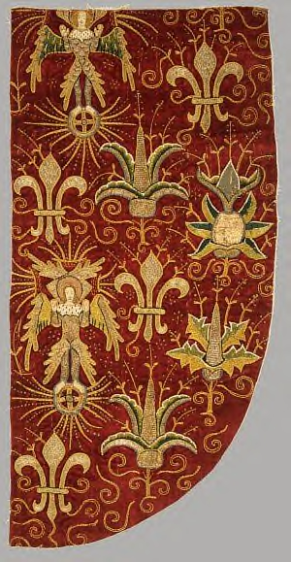
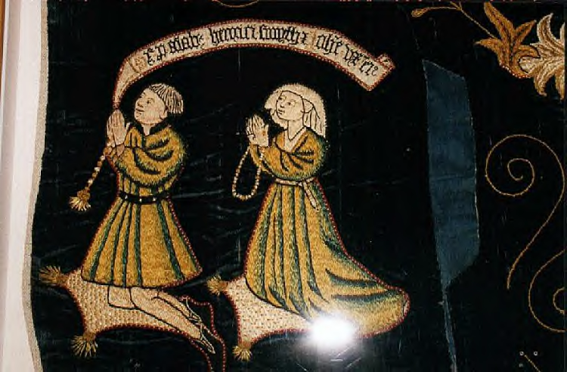
Opus Anglicanum (Chasuble), late 15th century
English
The Cloisters Collection, 1982 (1982.432)
Metropolitan Museum of Art
"Panel from an Altar Frontal or Dossal. Velvet with applied motifs of linen embroidered with silver-gilt and silk threads and with sequins in couched work and split stitch. English 1470-1500" V&A Museum Description

The fabric of both the banner, and its charge of crossed keys are of wool. Typically in our time period, banners were made of silk and silk satin. Although I spent more than 30 hours researching the use of wool for banners I have very little to offer as support for this. The term “bunting” is listed in the dictionary as being a wool used for creating banners and flags, although I cannot find a picture of a flag that I believe shows this example. The one reference I did find was of an estates inventory, listing woolen bunting purchased to create the Scottish Saint Andrews Flag: Bunting (also spelled Buntine) 1. The traditional woolen material from which flags are made. 2. Any fabric used in flag making. Note: According to Grace Rogers Cooper, prior to 1866 all woolen flag bunting used in the United (and Confederate) States was of British origin. 3. Plain, open weave cotton or worsted wool fabric that is piece-dyed and used for flags and decorations (Industrial Fabrics Association International). From Middle English bonting.( Illustrated Dictionary of Vexillology http://www.nava.org/Publications/dictionary/index.html Last Revision: June 1st 2001 )
The earliest record to the Saint Andrew's cross flag dates from 1165 AD, where reference is made to a 9th Century battle. This was known in the 16th Century, although no record of the original source remains today.

Significant chronology of the flag includes:
- 1180: The oldest extant record of the St. Andrews cross flag is on a seal in St. Andrews, where it is used as a religious, not a national, emblem
- 1286: the St. Andrews cross was first known to be a national emblem of Scotland (the seal of the guardians of Scotland).
- 1385: every Scots soldier used a saltire on his uniform (often used on black, not blue - the background colour seems to have been of less importance)
- 1388: the Standard of the Earl of Douglas used a St. Andrews cross and a lion
- 1503: the first certain use of a plain St. Andrew's Cross flag- but the field was red, not blue (the Vienna Book of Hours).
- 1512: the Lord High Treasurer's accounts mention the use of blue bunting.
- 1542: the first certain illustration of the St. Andrew's Cross on a blue field as we have it today (armorial of Sir David Lindsay).
- Reign of James IV: flagship Great Michael flew a flag with the St. Andrews cross and on the fly a red lion on yellow
- 1588: Scottish ship illustrated flying three saltires
- 1606: James VI (Scotland)/James I (England) combined the Scottish and English flags into the union flag of Great Britain
- 1707: Queen Anne continued using James VI/I's design. A Scottish version is also known, with the saltire over the St. George's cross
- 1801: the modern union flag introduced.
- 1970's: the Scottish saltire became much more prominently used in Scotland
- 1 July 1999: the union flagand the saltire were both used at the opening of the Scottish Parliament. Normally, though, only the Scottish saltire is flown.
1385: The ordinances for its use on soldier's uniforms read: 'Item every man French and Scots shall have a sign before and behind, namely a white St Andrew's Cross, and if his jack is white or his coat white he shall bear the said white cross in a piece of black cloth round or square'.
Two quotes from the Accounts of the Lord High Treasurer of Scotland:
1512: Payment for a roll of blue say (woollen bunting) for the banner of a ship 'with Sanct Androis cors in the myddis'.
1540: Delivered to be three ensigns for the ships sixteen 'elnis' red and yellow 'taffites'. Delivered to be the crosses thereof, four 'elnes' half 'elne' white 'taffities' of Genoa.
Graham Bartram, 15 August 2001; chronology augmented by Kenneth Campbell Fraser, 23 November
(From the Website “Flags of the World” http://flagspot.net/flags/gb-scotl.html Last modified: 2004-01-09)

I also found this reference:
CLXVII How to Lay Gold and Silver on Woolen Cloth
If you happen to have to work on woolen cloth, on account of tourneys or jousts, for gentlemen or great lords sometimes teem with desire for distinctive things, and want their arms in gold or silver on this sort of cloth: first, according to the color of the stuff or cloth, select the crayon which it requires for drawing; and fix it with a pen, just as you did on the velvet. Then take white of egg, well beaten as I taught you before, and an equal amount of size, in the usual way; and put it on the nap of this cloth, on the part where you have to do gilding. Then when it is dry take a crook, and burnish over this cloth; then apply two more coats of this tempera. When it is quite dry, apply your mordant so as not to go outside the tempered part, and lay whatever gold or silver you think fit.

(from: Cennino d'Andrea Cennini: The Craftsman's Handbook 1437)

The banner itself was machine stitched, with machine-stitched ties. Typically ties were not used, a ‘sleeve” that the pole passed through was more common, but due to the changing use in our mundane world which limit how they can be displayed, I felt “ties” would be more adaptable, allowing the most leeway in displaying it. I usually display it with a large tassel at the point, but removed it as I did not make it and did no research into that use of tassels.

The time spent creating this entry is approximately 40 – 50 hours, spread out over many months. The banner has been in use for a time, normal wear & tear is to be expected.

Bibliography:

Friar, S. and Ferguson, J. Basic Heraldry. 1993. The Herbert Press. ISBN: 0-7136-5119-9

Norris, Herbert Medieval Costume and Fashion 1993 Dover Publications ISBN 0-486-40486-2

Friar, Stephen A Dictionary of Heraldry 1987 Harmony Books ISBN: 0-517-56665-6

Fox-Davies, A.C. A Complete Guide to Heraldry 1909 Bonanza Books ISBN: 0-517-266431

Aspin, Chris The Woolen Industry Shire Publications Ltd., UK

Crowfoot, Elizabeth: Pritchard, Francis: and Staniland, Kay. Textiles and Clothing c. 1150-1450. London: HMSO, 1992.

Riek, Gustav. 1962. Der Hohmichele: ein Fürstengrabhügel der spãten Hallstattzeit bei der Heuneburg. Verlag Walter de Gruyter & Co., Berlin

The Compact Edition of the Oxford English Dictionary, Oxford University Press, 1971.

St. John Hope, W. H. Heraldry for Designers and Craftspeople Dover Publications ISBN: 0486404757

Beck, Thomasina. The Embroiderers Story; Needlework from the Renaissance to the Present Day 1995 David & Charles Publishers ISBN: 0-7153-0962-5

Cennino d'Andrea Cennini: The Craftsman's Handbook, The Italian "Il Libro dell' Arte." A Treatise on Painting, written by Cennino Cennini in the year 1437 Translated by Daniel V. Thompson, Jr. New York: Dover Publications, Inc. 1933, by Yale University Press. New York City; ISBN 0-486-20054

Woodcock, Thomas & Robinson, John Martin. The Oxford Guide to Heraldry Oxford University Press1988 ISBN: 0-19-211658-4
Kay Staniland, Medieval Craftsmen, Embroiderers, British Museum Press, London, 1991. (A good source for a wide range of metal thread embroidery). ISBN: 0802069150
Beryl Dean, Ecclesiastical Embroidery, Batsford, London, 1958, but several reprints.(Includes both period and modern embroidery, and good ‘how to’ information.) ASIN: 0713462523
Donald King and Santina Levey, The Victoria and Albert Museum’s Textile Collection: Embroidery in Britain from 1200 to 1700, Canopy Books, New York, 1993. (Large colour pictures of many metal thread embroideries from different periods.)

